**BREAST CANCER ACCURACY PREDICTION** **USING** **MACHINE LEARNING MODELS**

### Aim

To compare classification models in machine learning algorithms for predicting Breast cancer with good accuracy

#### Objectives

* To Prepare and Pre-process the dataset
* To Visualization the dataset
* To Perform Correlation Heatmap process
* To implement Different Classification model
* Analysing the data using performance metrics
* Evaluate using Ensemble model

**Method:**

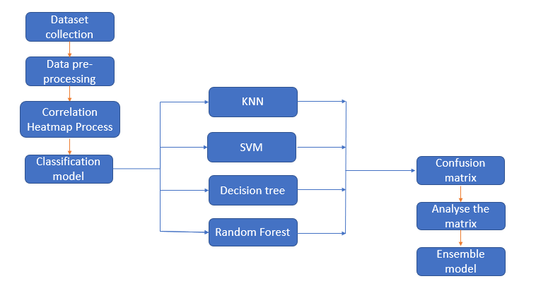

#### Dataset

The Molecular Taxonomy of Breast Cancer International Consortium (METABRIC) database is a Canada-UK Project which contains targeted sequencing data of 1,980 primary breast cancer samples. Clinical and genomic data was downloaded from cBioPortal.

The dataset was collected by Professor Carlos Caldas from Cambridge Research Institute and Professor Sam Aparicio from the British Columbia Cancer Centre in Canada and published on Nature Communications.

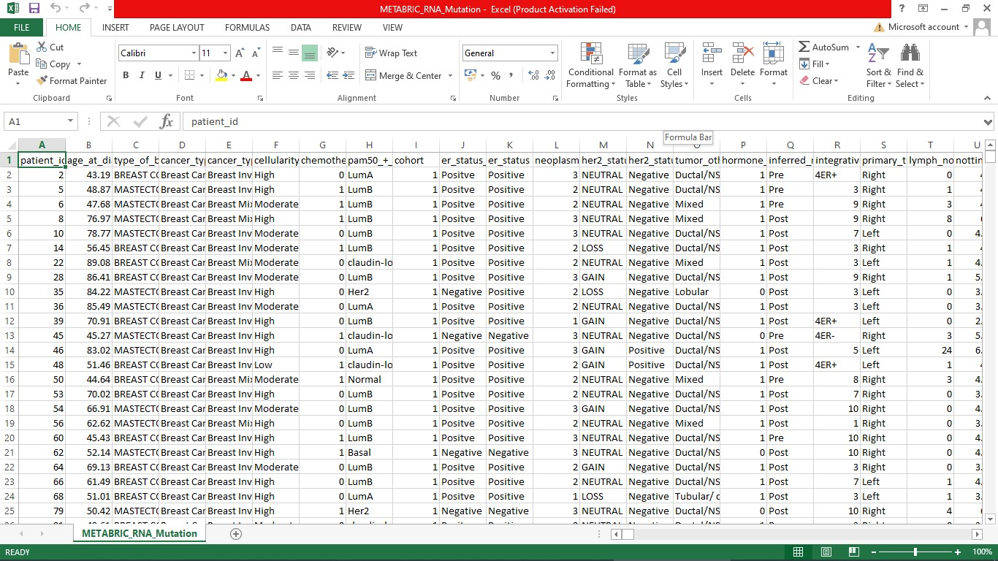

**Dataset**

### Source code

**Data Pre-processing & Correlation Heatmap Process**

import numpy as np

import pandas as pd

import seaborn as sns

import matplotlib.pyplot as plt

data pd.read_csv("/content/METABRIC_RNA_Mutation.cs")

X = data.iloc[:, 28:517].values

y = data.iloc[:, 4].values

from sklearn.preprocessing import LabelEncoder

label_encoder_y= LabelEncoder()

y= label_encoder_y.fit_transform(y)

**Correlation Heatmap for Gene Expression Profiles**

df = pd.DataFrame(X, columns=data.columns[28:517])

df['cancer_type_detailed'] = y

correlation_matrix = df.corr()

plt.figure(figsize=(20,24.5))

sns.heatmap(correlation_matrix, annot=False, cmap='coolwarm', fmt='.2f', linewidths=0.5)

plt.title('Correlation Heatmap for Gene Expression Profiles', fontsize=16)

plt.show()

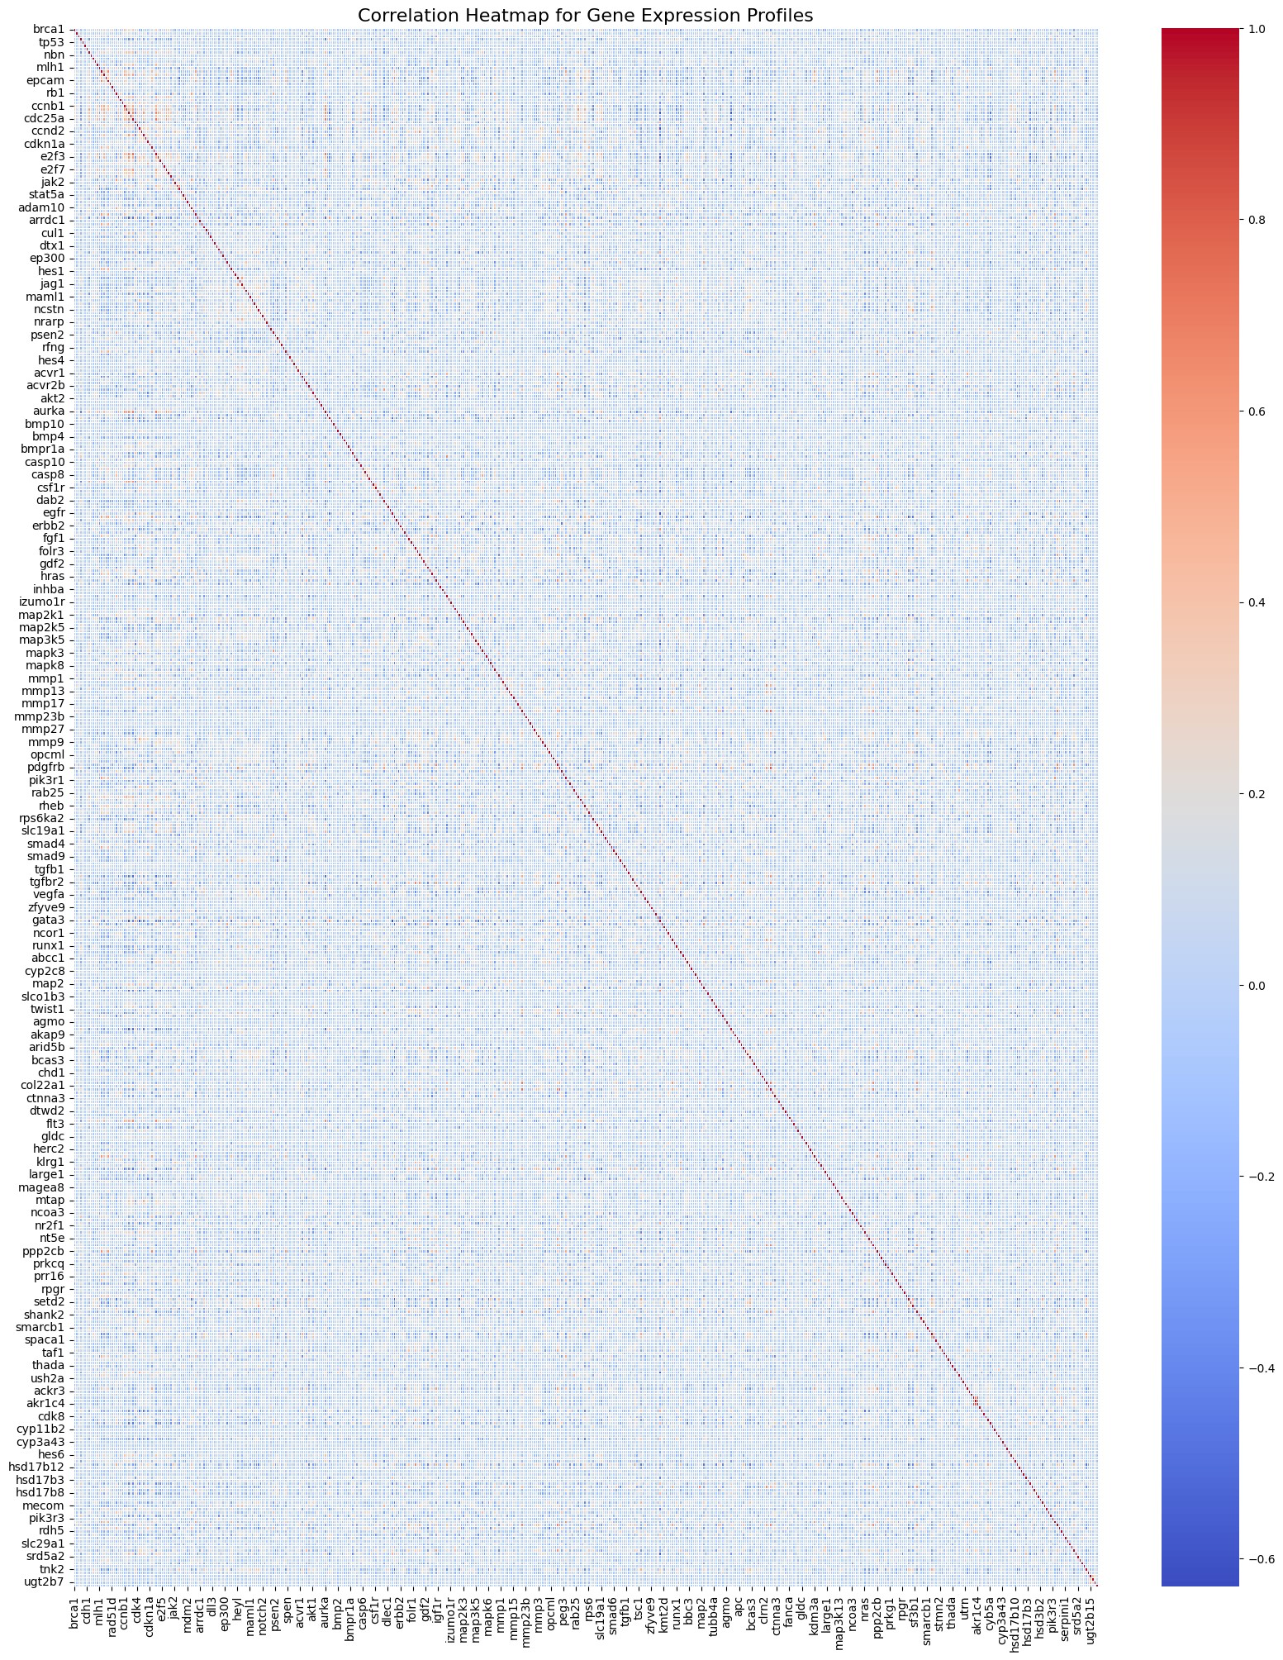

**Correlation Heatmap for Gene Expression Profiles**

correlation_with_target =

correlation_matrix['cancer_type_detailed'].abs().sort_values(ascending=False)

selected_features = correlation_with_target[1:]

correlation_threshold = 0.15

selected_features = selected_features[selected_features > correlation_threshold**]**

print(selected_features)

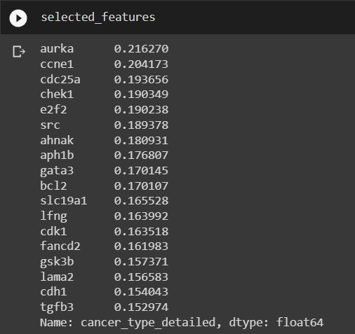

### Selected Gene Expression Profiles

**Correlation Heatmap for Clinical Features**

import numpy as np

import pandas as pd

import seaborn as sns

import matplotlib.pyplot as plt

from sklearn.datasets import load_breast_cancer

data=pd.read_csv("/content/METABRIC_RNA_Mutation.csv") X= data.loc[:, "cellularity":"death_from_cancer"]

y = data.iloc[:, 4].values

columns_to_encode = X.columns[:len(X.columns)]

label_encoder = LabelEncoder()

for column in columns_to_encode:

X[column] =label_encoder.fit_transform(X[column]) from sklearn.preprocessing import LabelEncoder label_encoder_y= LabelEncoder()

y= label_encoder_y.fit_transform(y)

df = pd.DataFrame(X, columns=data.columns[:28]) df['cancer_type_detailed'] = y correlation_matrix = df.corr() plt.figure(figsize=(28, 28))

sns.heatmap(correlation_matrix, annot=True, cmap='coolwarm', fmt='.2f', linewidths=0.5)

plt.title('Correlation Heatmap for Clinical Features', fontsize=16)

plt.show()

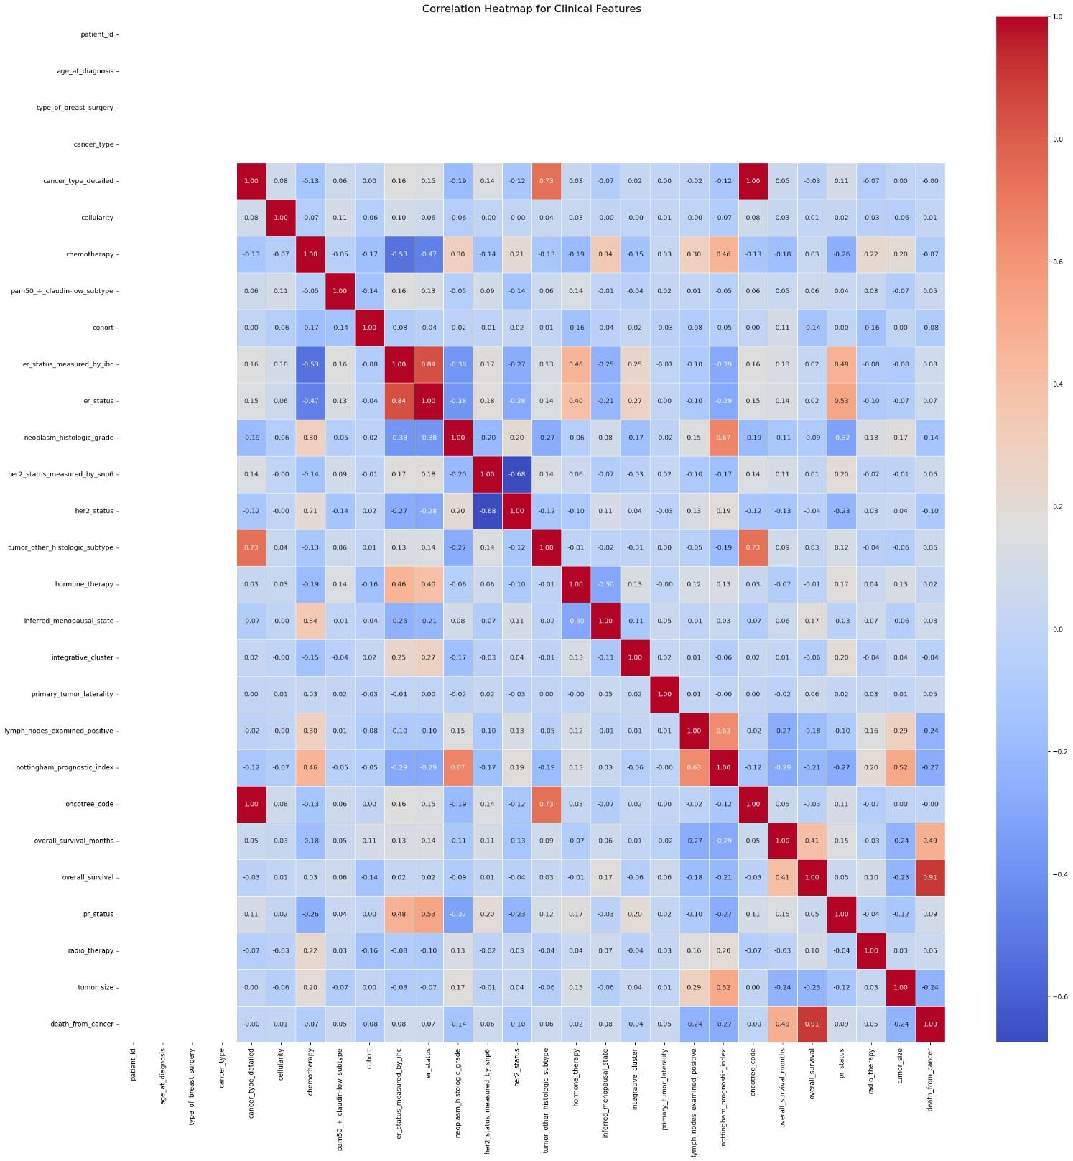

### Correlation Heatmap for Clinical Features output

correlation_with_target = correlation_matrix['cancer_type_detailed'].abs().sort_values(ascending=False)

selected_clinical_features = correlation_with_target.drop('cancer_type_detailed').index

correlation_with_target = correlation_matrix['cancer_type_detailed'].abs().sort_values(ascending=False)

selected_features = correlation_with_target[1:]

correlation_threshold = 0.1

selected_features = selected_features[selected_features > correlation_threshold]

selected_features

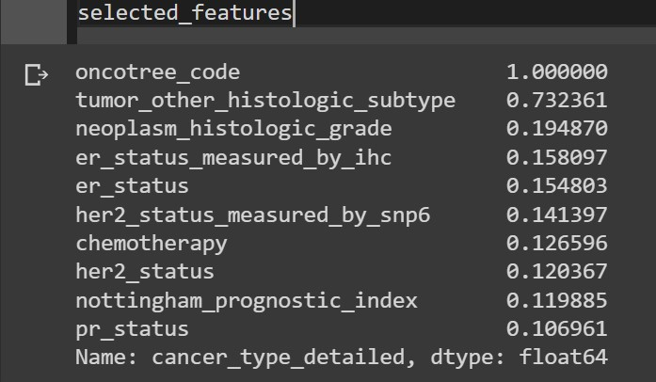

### Selected Clinical Features

#### Data Pre-Processing & Mechine learning models

#### import numpy as np

#### import pandas as pd

from sklearn.model_selection import train_test_split

from sklearn.preprocessing import StandardScaler from sklearn.svm import SVC

from sklearn.metrics import accuracy_score, classification_report, confusion_matrix y= data[['cancer_type_detailed']]

X=data[['oncotree_code','tumor_other_histologic_subtype','neoplasm_histologic_grade','er_status_measured_by_ihc','er_status','her2_status_measured_by_snp6','chemotherapy','her2_status','nottingham_prognostic_index','pr_status','aurka','ccne1','cdc25a','chek1','e2f2','src','ahnak','aph1b','gata3','bcl2','slc19a1','lfng','cdk1','fancd2','gsk3b','lama2' ,'cdh1','tgfb3']]

columns_to_encode =X.columns[:len(X.columns)]

label_encoder = LabelEncoder()

for column in columns_to_encode:

X[column] = label_encoder.fit_transform(X[column])

X_train, X_test, y_train, y_test = train_test_split(X, y, test_size=0.2, random_state=42) scaler = StandardScaler()

X_train_std = scaler.fit_transform(X_train)

X_test_std = scaler.transform(X_test)

**KNeighbor (K-NN)**

from sklearn.neighbors import KNeighborsClassifier classifier= KNeighborsClassifier(n_neighbors=5, metric='minkowski', p=2 ) classifier.fit(X_train, y_train)

y_pred= classifier.predict(X_test) cm= confusion_matrix(y_test, y_pred) K = accuracy_score(y_test, y_pred) classification_rep = classification_report(y_test, y_pred) print("Accuracy:", K ) print("Confusion Matrix:\n", cm) print("Classification Report:\n", classification_rep)

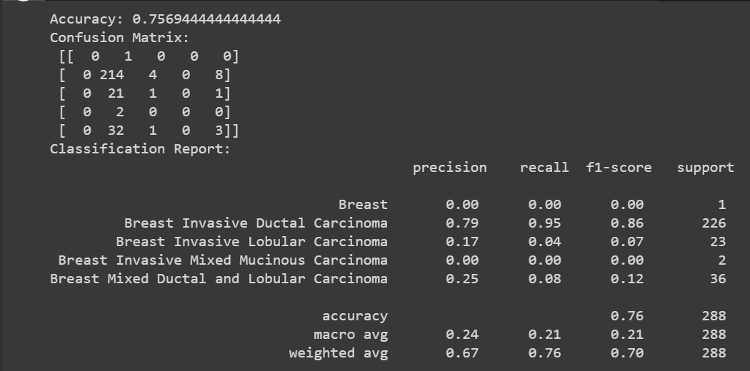

### Accuracy Score, Confusion Matrix and Classification Report for KNeighbor (K-NN)

**Support Vector Machine (SVM)**

svm_model = SVC(kernel='linear', random_state=42) svm_model.fit(X_train_std, y_train)# Make predictions on the test set y_pred = svm_model.predict(X_test_std)# Evaluate the model's performance accuracy = accuracy_score(y_test, y_pred) confusion = confusion_matrix(y_test, y_pred) classification_rep = classification_report(y_test, y_pred) print("Accuracy:", accuracy) print("Confusion Matrix:\n", confusion) print("Classification Report:\n", classification_rep)

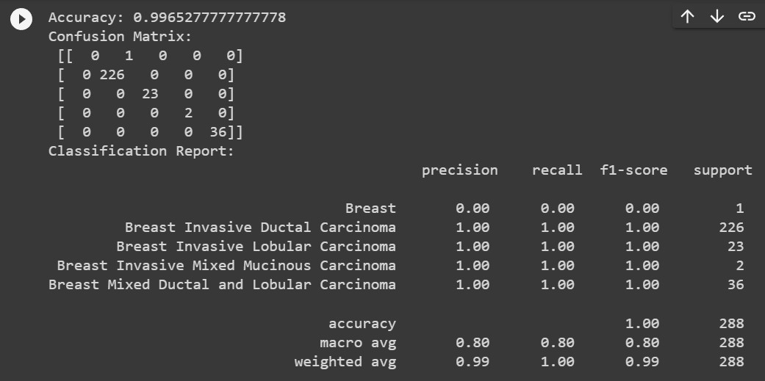

### Accuracy Score, Confusion Matrix and Classification Report for Support Vector Machine (SVM)

**Decision Tree**

from sklearn.tree import DecisionTreeClassifier classifier= DecisionTreeClassifier(criterion='entropy', random_state=0) classifier.fit(X_train, y_train)#Predicting the test set result y_pred= classifier.predict(X_test) cm= confusion_matrix(y_test, y_pred) d = accuracy_score(y_test, y_pred) classification_rep = classification_report(y_test, y_pred) print("Accuracy:", d ) print("Confusion Matrix:\n", cm) print("Classification Report:\n", classification_rep)

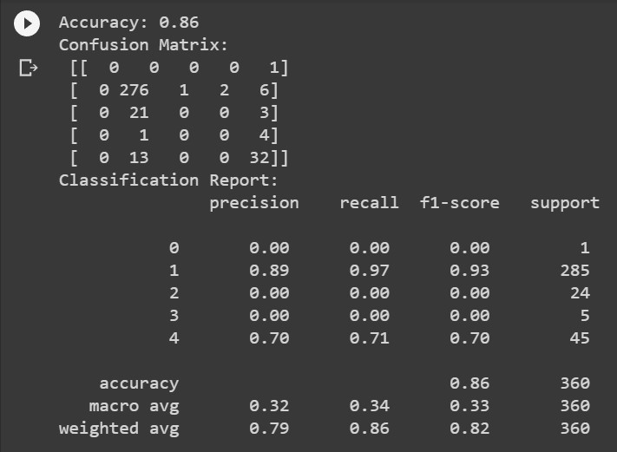

### Accuracy Score, Confusion Matrix and Classification Report for Decision Tree

**Random Forest**

from sklearn.ensemble import RandomForestClassifier classifier= RandomForestClassifier(n_estimators= 10, criterion="entropy") classifier.fit(X_train, y_train)#Predicting the test set result y_pred= classifier.predict(X_test) cm= confusion_matrix(y_test, y_pred) r= accuracy_score(y_test, y_pred) classification_rep = classification_report(y_test, y_pred) print("Accuracy:", r ) print("Confusion Matrix:\n", cm) print("Classification Report:\n", classification_rep)

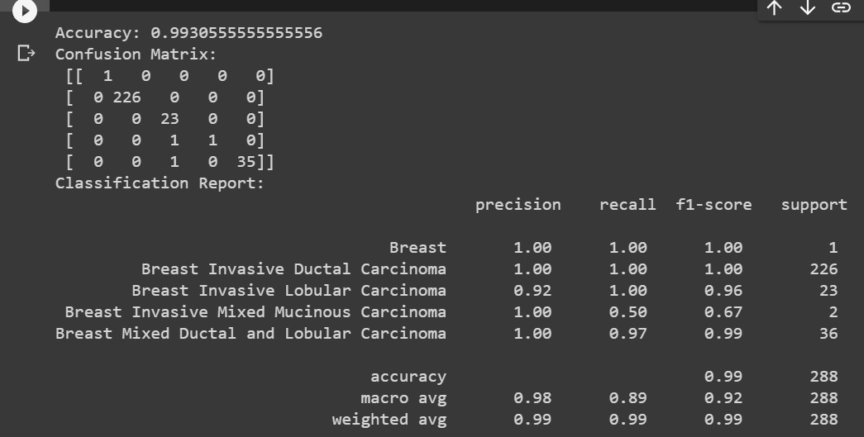

### Accuracy Score, Confusion Matrix and Classification Report for Random Forest

#### Different ensemble models

**Gradient Boosting**

from sklearn.ensemble import GradientBoostingClassifier

gradient_boosting_model = GradientBoostingClassifier(n_estimators=100, random_state=42)

gradient_boosting_model.fit(X_train_std, y_train)# Make predictions on the test set

y_pred = gradient_boosting_model.predict(X_test)# Evaluate the model's performance g = accuracy_score(y_test, y_pred) confusion = confusion_matrix(y_test, y_pred) classification_rep = classification_report(y_test, y_pred) print("Accuracy:", g) print("Confusion Matrix:\n", confusion) print("Classification Report:\n", classification_rep)

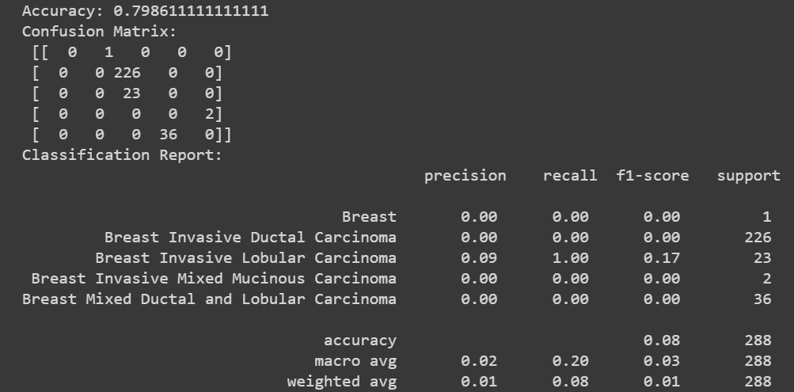

### Gradient Boosting

#### Stacking Classifier

from sklearn.ensemble import RandomForestClassifier,

GradientBoostingClassifier from sklearn.svm import SVC

from sklearn.ensemble import StackingClassifier from sklearn.linear_model import LogisticRegression from sklearn.model_selection import cross_val_predict random_forest = RandomForestClassifier(random_state=42) svm = SVC(probability=True, random_state=42) logistic_regression = LogisticRegression(random_state=42) stacked_model = StackingClassifier(

estimators=[('rf', random_forest), ('svm', svm), ('lr', logistic_regression)], final_estimator=LogisticRegression(),

)

stacked_model.fit(X_train, y_train) y_pred_stacked = stacked_model.predict(X_test) st = accuracy_score(y_test, y_pred_stacked) confusion = confusion_matrix(y_test, y_pred_stacked) classification_rep = classification_report(y_test, y_pred_stacked) print("Accuracy:", st)

print("Confusion Matrix:\n", confusion) print("Classification Report:\n", classification_rep)

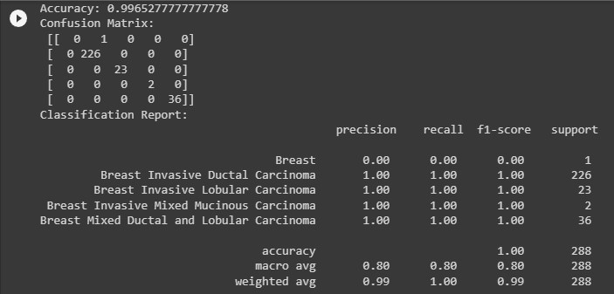

### Accuracy Score, Confusion Matrix and Classification Report

### for Stacking Classifier

**Voting classifier**

from sklearn.ensemble import VotingClassifier

# Initialize the base models model1 = DecisionTreeClassifier() model2 = LogisticRegression() model3 = SVC(probability=True) model4 = GaussianNB() model5 = KNeighborsClassifier() model6 = RandomForestClassifier() ensemble_model = VotingClassifier( estimators=[

('dt', model1),

('lr', model2),

('svc', model3),

('gnb', model4),

('knn', model5),

('rf', model6)

],

voting='hard'

)

ensemble_model.fit(X_train, y_train) y_pred = ensemble_model.predict(X_test)

print("-------------------------------------------------------------------voting model------------

------------------------------------------------------------")

e = accuracy_score(y_test, y_pred) confusion = confusion_matrix(y_test, y_pred) classification_rep = classification_report(y_test, y_pred) print("Accuracy:", e) print("Confusion Matrix:\n", confusion) print("Classification Report:\n", classification_rep)

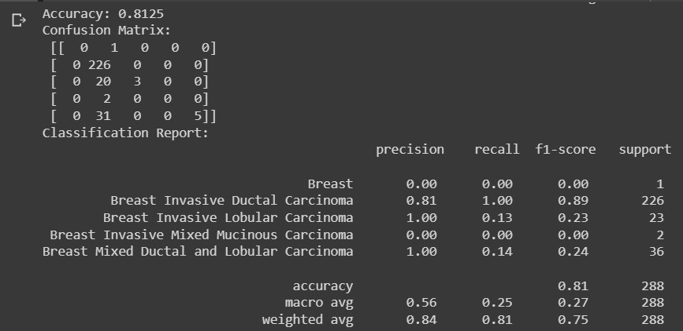

### Accuracy Score, Confusion Matrix and Classification Report for voting model (hard)

print("----------------------------------------------------------------Averaging model---------

---------------------------------------------------------------")

averaging_model = VotingClassifier( estimators=[

('dt', model1),

('lr', model2),

('svc', model3),

('gnb', model4),

('knn', model5),

('rf', model6)

],

voting='soft'

)

averaging_model.fit(X_train, y_train) # Make predictions on the test set y_pred = averaging_model.predict(X_test) a = accuracy_score(y_test, y_pred) confusion = confusion_matrix(y_test, y_pred) classification_rep = classification_report(y_test, y_pred) print("Accuracy:", a) print("Confusion Matrix:\n", confusion) print("Classification Report:\n", classification_rep)

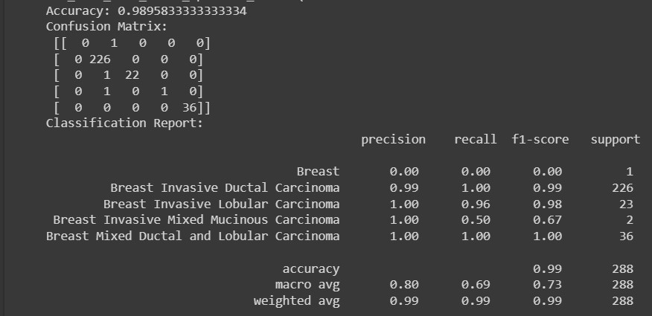

**Accuracy Score, Confusion Matrix and Classification Report for Averaging model(soft)**

### Result

***Machine Learning models Results***

|  |  |  |
| --- | --- | --- |
| **S.no** | **Machine Learning models** | **Accuracy score** |
| 1 | K-NN classifier | 0.7569444444444444 |
| 2 | Support Vector Machine | 0.9965277777777778 |
| 3 | Decision Tree | 0.86 |
| 4 | Random Forest | 0.9930555555555556 |

***Different ensemble models Results***

|  |  |  |
| --- | --- | --- |
| **S.no** | **Ensemble Models** | **Accuracy score** |
| 1 | Gradient Boosting | 0.798611111111111 |
| 2 | Stacking Classifier | 0.9965277777777778 |
|  | **Voting classifier** |  |
| 3 | Voting model | 0.8125 |
| 4 | Averaging model | 0.9895833333333334 |